33.62: a) By the symmetry of the triangles, 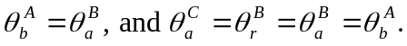
Therefore,
b) The total angular deflection of the ray is:
c) From Snell’s Law, sin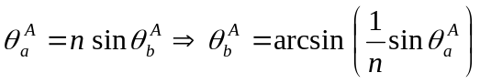
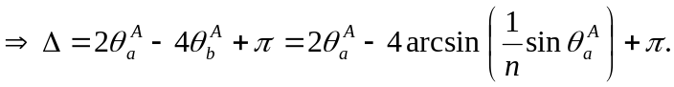
d) 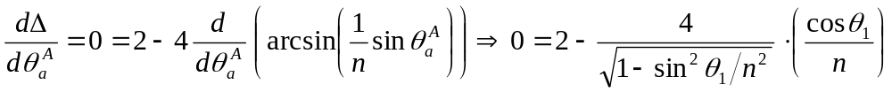

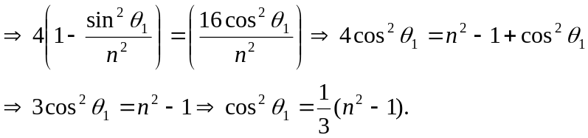
e) For violet: 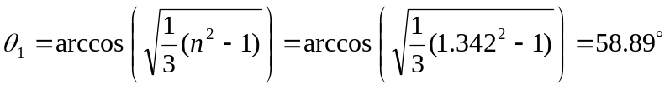
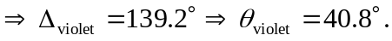
For red: 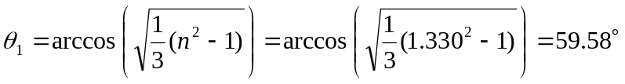
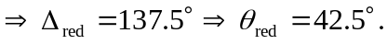
Therefore the color that appears higher is red.

